ELEC0019 Interference, Diffraction and Polarization of Electromagnetic Waves

**Abstract -- The lab is held for Year two students to introduce interference, diffraction and polarization of electromagnetic waves. The lab session is a remote task, aiming at analyzing the recorded data with the help of MATLAB. In each part of the lab, student firstly do the self-study with the concept and the physical phenomenon and derive mathematical expressions for the ideal results. By comparing the measured results and the expected results, students would analyze the difference and find out the influencing factors. All the pre-derived formula describes the physical phenomenon in general while shows a kind of uncertainties under the physical environment.**

**Introduction**

**Young’s double slit experiment illustrates the wave-like nature of light, a kind of electromagnetic wave. Based on the experiment and the previous theory with light, wave-particle duality of light was gradually recognized, pushing the understanding of electromagnetic as well. This term, Electromagnetic Theory is taught. Students would learn basic knowledge about electromagnetic and wave propagation (plane waves and guided waves). The lab is set up to give students an opportunity to study the concepts of interference, diffraction and polarization. The las session shows the mathematical method of finding the expression for intensity, the relative permittivity and the absolute value of the far filed. The establishment of mathematical models, the presentation of experimental data and analysis would be shown in each part and lead to deeper thinking of the knowledge.**

**Part 1 Interference of waves**

**Q1. Since the intensity here is defined as the squared amplitude of the electric field, we get where indicates the intensity and is the amplitude of the electric field.**

**Put , , and into .**

**We get .**

**Let and , the expression for could be simplified as .**

**Based on Euler’s formula , and .**

**Put into .**

**Similarly, put into .**

**Since , the magnitude of is .**

**Hence, .**

**And the expression for the intensity () is which is a periodical function.**

**The maximum value for the intensity is when the value of equals to . And the minimum value for the intensity is when the value of equals to .**

**The period for the function () is . The period () is which is the distance between adjacent maxima (or minima).**

**Q2. The graph to compare the predicted interference patterns based on *eqn. (1)* and *eqn. (4)* are shown in *Graph 1*. [1]**

*Graph 1 - A MATLAB graph for comparing the equations describing the intensity*

**The approximations used in *eqn. (4)* is reasonable since both the plots illustrate a quite similar distribution and characters. Both the graphs are symmetrical around the line . The center of both the most center strip stays at the line . The width of each strip generated by the same equation is same. And the minimum values of each curve are zero. Compared with the graph plotted by *eqn. (1)* with that by *eqn. (4)*, the graph plotted by *eqn. (4)* shows a sharper top and wider bottom and the contrast become more obvious with the increasing distance from the center of screen. The graph plotted by *eqn. (4)* is more concentrated, which means the center of each strip is closer to the center of the whole graph.**

**In order to make the assumption, the sine term was substituted into and the cosine term was substituted into . Hence, we would compare the difference between and and the difference between and . Based on the MATLAB code named** *Interference.m***, the maximum value of is (shown in *Figure 1*) so the sketches for comparison were plotted within the range . It could be seen that the value of is slightly larger than that of (shown in *Graph 2*), while there is no difference between and (shown in *Graph 3*). Therefore, the difference between the graph plotted by *eqn. (1)* and *eqn. (4)* was caused by the assumption of the sine term. The approximation enlarged the value of , causing the same effect as larger separation between the sources or shorter distance from sources to screen.**

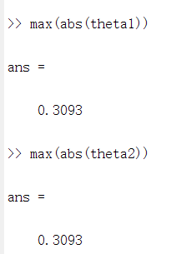

*Figure 1 - A screenshot for the values of the maximum values of theta*  *Graph 2 - Comparison of y = x and y = sin(x)*

*Graph 3 - Comparison of y = 1-x^2/2 and y = cos(x)*

**Experiment 1.1: Interference of waves**

**Q3. The detector diode is used to demodulate the detected signal. It could change alternating current to direct current, eliminating the negative part of the current. The frequency of the signal carried by the coaxial cable to the meter is in this case since the microwave was modulated by the square wave signal. The increase of the current of the signal (current) coming from the detector through the coaxial cable leads to the squared rise with the electric field intensity received by the horn. This is because based on the Ohm’s law, the relationship between the voltage and the current is where representing the current, representing the voltage and representing the resistance. Hence, the relationship between the current and the electric field intensity (indicated as ) is . Thus, the output is proportional to . The reason is that the squared of the amplitude of the signal is proportional to the energy. By assuming the distance between the rectangular waveguide and the waveguide horn is constant, the loss would be the same. Thus, the amplitude of the received signal might be smaller than that coming from the waveguide. In that case, the magnitude of the energy would reduce a little while does not affect the general trend and the general shape.**

**Q4. The graph to compare the difference between the predicted interference pattern based on *eqn. (1)* and the experimental data stored in *Int 1.txt* is shown in *Graph 4*. [1] [2]**

*Graph 4 - A MATLAB graph to compare the ideal interference pattern and the experimental result*

**From *Graph 4*, it could be seen that the maxima are not same as each other and the values of the amplitudes of the minima are not zero. The maxima occurred at the center and then the maxima for each circle decreased with the rise of the distance from the center of screen. The minima showed less change in each circle. The maxima would offer a more accurate definition of position since the shape of the maxima is more shaper which means the change of the magnitude of the relative intensity would be more obvious. Therefore, it is much easier to distinguish the maximum values and hence the position of the maximum values while the opposite is true for the minima.**

**To find the reliable of the approximations, a combination graph of the expression from *eqn. (1)*, the expression from *eqn. (4)* and the experimental data from *Int1.txt* should be plotted with MATLAB as shown in *Graph 5*. [1]**

*Graph 5 - Combination graph for expected pattern (based on eqn. (1) and eqn. (4) respectively) and the experimental data*

**From *Graph 5*, it could be seen that in terms of the overall shape, the approximations fitted the experimental results by using the expression for *eqn. (4)*. However, they did not work well for the extremums although they performed better when compared with the ideal one which is calculated from *eqn. (1)*. For the maxima, the experimental results would be shaper than the calculated ones. And for the minima, the experimental results would be wider than the calculated ones. The values of maxima go lower with the increasing distance from the center of the screen.**

**In this case, the wave is transmitted in the plane with the electric field in the direction, perpendicular to the plane. However, if the electric fields are changed in the plane instead, the wave would propagate in the direction. Thus, the horn would not receive any signal since it does not stay in the plane where the wave propagates. When replacing the horn as a finite aperture, more background signal and the signal at the other point might be detected, introducing uncertainties to the system.**

**Experiment 1.2: Measurement of relative permittivity of a dielectric material**

**Q5. Relative permittivity is defined as the ratio between the actual permittivity of a medium and the absolute permittivity of vacuum, which could be written as where represents the relative permittivity, represents the actual permittivity and represents the absolute permittivity of vacuum.**

**The path difference is defined as the multiplication between the thickness of the slab and the difference between the refractive index of difference path, which could be written as where represents the thickness of the slab and represents the refractive index. [3]**

**The refractive index of the material can be expressed in terms of electric permittivity (indicated as ) and magnetic permittivity (indicated as ). And based on different expressions for the Snell’s Law (i.e., and , it could be seen that .**

**Therefore, the expression for the path difference could be written as . [4]**

**In the question, the expression for path difference is where is the electric permittivity in the air which equal to 1. So .**

**Based on *Figure 3 in lab script* [5], we could get a figure as shown in *Figure 2*.**

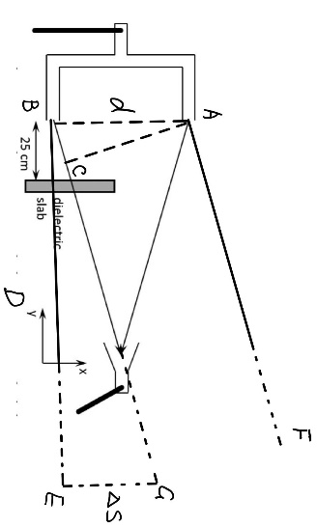

*Figure 2 - A draw to derive the expression of relative permittivity*

**Draw a vertical line passing through point A to make BG intersects at point C. In this question, we assume that . Based on the definition of limit, the line AF and BG will intersect at the end (i.e., the horn), forming an isosceles triangle with two bottom corners equaling to . Therefore, BC is the path difference. Point E is the central of the previous central maxima, making BE is a horizontal line. GE is a line on horn. Assuming the horn is placed vertical, GE is perpendicular to BE. The angle and the angle are . The angle and the angle are the same magnitude and so does the angle and the angle . Hence, the triangle and the triangle are similar triangles. Therefore, we get .**

**Therefore, the path difference is .**

**Since we know that . We could get**

**So, the relative permittivity of the sheet is given by where is the shift of the central maximum along the x-axis, and is the thickness of the dielectric sheet.**

**Q6. The graph for the comparison between the received signal and the shifted one could be plotted by MATLAB as shown in *Graph 6*. [2] [6]**

*Graph 6 - A MATLAB graph shows the shift of the interference pattern*

**The overall shapes for both curves are same to each other. The central one shows the maximum relative intensity. With the increase distance from the central, the relative intensity decreases. Both curves show a shaper top and a wider bottom. In order to find the shift of the pattern, we could find the shift for each maxima and then find the average of those shift. The MATLAB code for shift finding is attached in the appendix.**

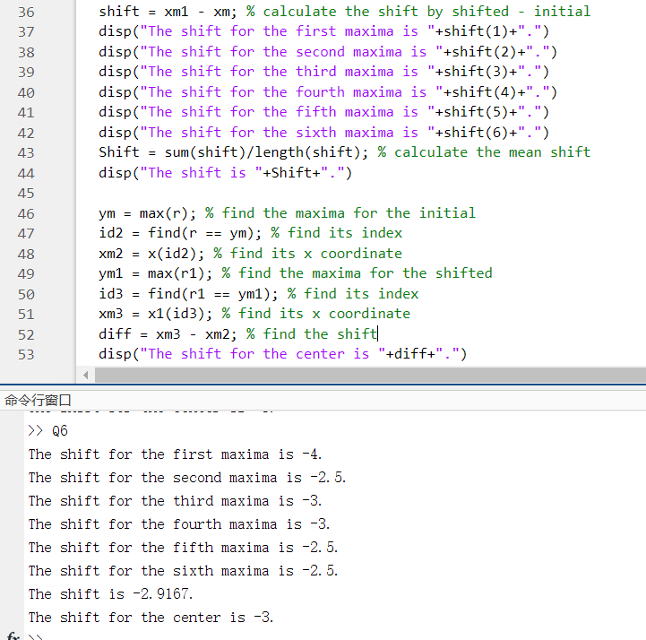

*Figure 3 - A screenshot of MATLAB showing the shift for each maxima, the average maxima and the center*

**It could be seen from *Figure 3* that the magnitude of the shift for each maximum value is , , , and . And the magnitude of the mean shift is which is quite close to the shift of the center (the magnitude of which is ).**

**In order to calculate the value of the relative permittivity of the dielectric slab with , we would use with all the parameters (i.e., , , and ) in .**

**This would not be suitable for thick sheets and same for high permittivity sheets. *Figure 4* illustrates the difference. This is because larger or larger wound introduce more errors to the final result. This could be explained in the following figures. With same incident light, when , , where black arrows represent for actual path while green arrows represent for the path without sheet. With same incident light, when , , where black arrows represent for actual path while green arrows represent for the path without sheet.**

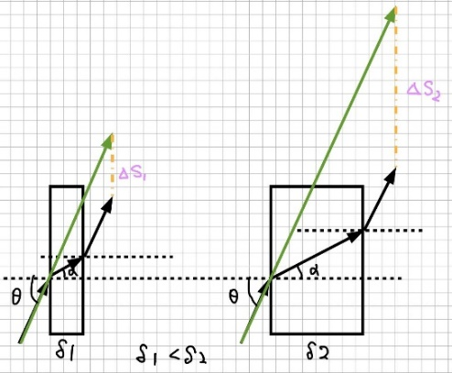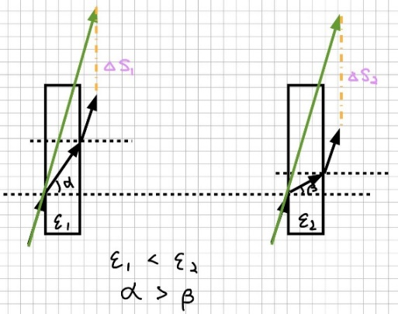

*Figure 4 - Showing the impact of thickness of the sheet (left) and the relative permittivity of the sheet (right) on the shift of the interference pattern*

**The distance between the slab and one of the terminals of the rectangle terminal does not affect the final pattern, which means it does not need to be exactly . This is because the path difference caused by the slab does not change no matter where it is as long as it meets the requirement that which is stated in *Q5*.**

**Experiment 1.3: Antenna Arrays**

**Q7. To fund to absolute value of *eqn. (6)*, common factors could be found in the expression .**

**The magnitude of is .**

**Based on Euler’s formula , and . So, we get which is in the form of with . The factor is called the radiation pattern of the array (i.e., the Array Factor).**

**With the expression for the array factor , we could get plots of versus as shown below. We know that the definition for is thus . When , , thus . Similarly, when , , thus . All the graphs are shown from *Graph 7* to *Graph 12*.**

1. **and**

*Graph 7 - When d is lambda/2 and phi is 0*

1. **and**

*Graph 8 - When d is lambda/2 and phi is 90*

1. **and**

*Graph 9 - When d is lambda/2 and phi is 180*

1. **and**

*Graph 10 - When d is lambda/4 and phi 0*

1. **and**

*Graph 11 - When d is lambda/4 and phi is 90*

1. **and**

*Graph 12 - When d is lambda/4 and phi is 180*

**Part 2 Diffraction and Polarization**

**Q9. Diffraction would occur when a wave encounters a gap or an obstacle with the similar magnitude of size of the wavelength. The closer the size of the gap or obstacle to that of the wavelength, the more obvious the phenomenon of diffraction would occur. Fresnel diffraction is near field while Fraunhofer diffraction is far field. Fresnel approximation assumes parabolic wavefronts while Fraunhofer approximation assumes planar wavefronts. [7] In Experiment 2.1, distance (i.e., the value of ) would be the main factor to consider which diffraction theory should be used.**

**Q10. Refraction is the change of the direction of the light since the light travels from one medium to another. Refraction changes the wavelength and the speed of the light. The phenomenon of refraction depends on the wavelength of the light, the incident angle and the refractive indexes of the mediums. Refraction shows the particle-like nature of photons. However, diffraction bends the light around an opening or an obstacle which does not change the wavelength and the speed of the light. The phenomenon of diffraction depends on the wavelength of the light and the scale of the opening or the obstacle. Diffractions shows the wave-like nature of photons. Both diffraction and refraction are wavelength dependent, splitting white light into its component wavelengths. Diffraction of light creates a fringe pattern, while refraction creates an optical illusion instead of a fringe pattern. [8]**

**Microwave communication system uses the electromagnetic wave with wavelength ranging from to . When meeting a gap or an obstacle having a similar size with the wavelength of the wave, diffraction would occur. If the obstacle is too larger (i.e., a mountain, for example), diffraction could not occur so the signal may be attenuated, and even disappear. Therefore, microwave communication is line-of-sight communication, requiring the help of microwave relay stations.**

**When a white light incident on a grating, the light would be separated due to diffraction. Based on the formula, where is the distance between slits, is the diffraction angle, is the order number for the maximum and is the wavelength of the light, the diffraction angle would be affected by different wavelength (i.e., ). With the same order and the same distance between the slits, the shorter the wavelength is, the smaller the value of would be and the smaller the diffraction angle would be, causing the fringe stay further from the central. The analysis above is shown in *Figure 11*.**

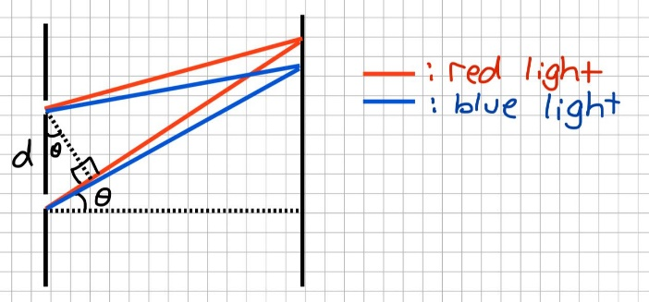

*Figure 5 - A draw to show the separation of the white source*

**Experiment 2.1: Diffraction of a wave by a conducting place**

**Q11. The diffraction pattern based on the experimental data is plotted by MATLAB and shown in *Graph 13*.**

*Graph 13 - Diffraction pattern plotted based on the experimental data with a mark of the point when x = 0*

**It could be seen in the graph above that the corresponding relative intensity when is about .**

**When there is an opaque screen, a plane wave would be partially blocked, causing shadow to some extends. Since the value of intensity is proportional to the squared of the magnitude of the amplitude of the signal, when the screen occludes half of the wave, the magnitude of the intensity would decrease to a quarter of its initial value. Thus, the theoretical value would be . The result from *Fresnel diffraction on a semi-infinite opaque screen* written by *Loenen, S.J.H.* in 2015 [9] shows a similar conclusion which is shown in *Figure 6*.**

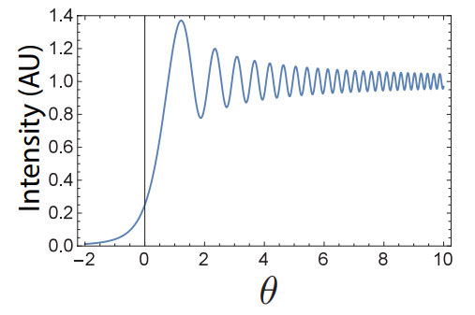

*Figure 6 - A sketch of Fresnel diffraction plotted in a published print*

**In terms of Fraunhofer diffraction (i.e., far-field diffraction), an excitation, taking** spherical wave as example, would show a wider pattern with less intensity at each corresponding points compared with a plane wave. If both the distance between the generator and the screen and the distance between the screen and the horn increase, the wavefront would be more like a plane which fits the condition for using Fraunhofer assumption to analyze diffraction.

**A conducting screen would not correspond with an opaque screen well. Conducting materials are mainly considered as metal while metal would reflect most of the electromagnetic wave while would reduce the overall incident wave due to the superposition of the wave. The detected intensity at the horn for an orthogonal polarization would decrease by half compared with a normal polarization. This is because the orientations of an orthogonal polarization are horizontal and vertical. Based on the concept of polarization, only one of them could pass a polarizer.**

**When the receiving horn moving along the x-axis, the trend would be opposite with the situation where the screen is moving along the x-axis. For instance, when the receiving horn moves upward, the detected intensity would rise while the intensity would reduce if the screen moving upward.**

|  |  |  |
| --- | --- | --- |
|  | ****Near Field**** | ****far field**** |
| ****diffraction**** | **Fresnel** | **Fraunhofer** |
| ****wavefronts**** | **Parabolic** | **Planar** |
| ****approximation**** |  |  |

Table 1 *- A table compares the difference between near field and far field [7]*

**Polarization of Electromagnetic Waves**

**Q13. The polarization of an electromagnetic wave is the direction of the oscillation of the electric field (i.e., horizontal or vertical).**

**Polarizers are films made by artificial methods. Polarizers could make an unpolarized wave polarize obviously in some specific forms. Polarization could attenuate and block high-energy light and minimize the effect of reflected lights. Light is reflected when it hits a smooth surface, causing glare. The lens of the anti-glare sunglasses contains a layer of polarizer which could reduce the intensity of the incident light by polarizing the light and absorb the reflected light. This is because reflected light is polarized in horizontal. However, the lens of sunglasses is a kind of vertical polarizer. Thus, the orientations of the light and lens are perpendicular to each other, and hence, reducing glare.**

**When there is a polarizer between a source emitting a polarized file and a receiver, the signal would only remain the components in the same direction with the orientation of the polarizer after passing through the polarizer. When rotating the polarizer from to , the intensity of the light would vary from the maximum when the direction of the vibration of the photons in the same direction of the polarizer (i.e., when ) to zero when the direction of the vibration of the photons is perpendicular to that of the polarizer (i.e., when ), then return to the maximum when the direction of the vibration of the photons back to the same direction of the polarizer (i.e., when ). The same process would repeat when the polarizer rotates in the following half cycle (i.e., from to ). The process described above is shown in *Figure 7*.**

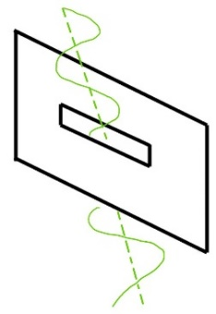f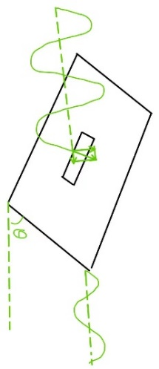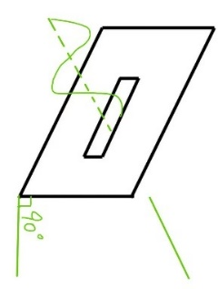

*Figure 7 - Rotating a polarizer*

**The relationship between the detected amplitude (indicate as ) and the angle is , where is the amplitude of the polarized light. Since there is a relationship between the intensity (indicated as ) and the amplitude , the expression above could be rewritten as which is called Malus’ Law [10].**

**By assuming the value of is , a graph of intensity against angle could be drawn by MATLAB as shown in *Graph 8*.**

*Graph 14 - A sketch of the detected intensity against the angle when the polarizer is rotating*

**Experiment 2.2: Polarization**

**Q14. The polarization of the emitted wave should be horizontal. As shown in *Figure 8* [11], with the rise of the wavelength, the corresponding photoelectron energy is increasing. In the question, as said in the question, its longer** side is horizontal**, causing a relatively larger wavelength, leading to a more obvious polarization. Thus, the received intensity in horizontal is much larger than that received in vertical.**

*Figure 8 - "Experimental photoelectron spectra of Xe ionized by the linearly polarized laser field at the two wavelengths of 800nm and 1500nm"*

**From the table provided in the question, the horizontal components of the received signal for both screens are much larger than the vertical components of the received signal for both. Therefore, the polarization of the received signal is horizontal. However, the orientation of the received signal after the wire grid is perpendicular to that of the source signal. Thus, the polarization of the source signal is vertical. The result does not coincide my expectation for this source. This is because that the wire grid works in an opposite way compared with the normal polarizer as shown in *Figure 9* [12].**

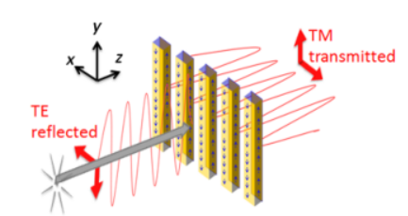

*Figure 9 - Principle of the wire-grid polarizer*

**The electrons inside the wire would absorb energy from the electromagnetic wave (i.e., the electric field component), reducing the intensity of the wave. When the electric field component is parallel with the screen, the energy would be absorbed and hence, dropping the intensity of the wave, and vice versa.**

**The wire grid screen would provide more efficiency compared with the performance of the wire mesh screen. This is because the wire in the wire grid screen has signal direction while that in the wire mesh screen has two directions. The orientation of the wire would define the polarization of the output wave. For instance, when the wire is placed in horizontal, the wave with horizontal polarization would be blocked completely and the wave with vertical polarization would pass completely in the ideal situation. However, the wire mesh would block all kinds of wave to some extends which is related to the angle formed by the wires in the screen. When a wave is multi-polarization, the wire grid screen would only allow the specified component pass while the wire mesh screen would allow all the components pass except the specified component.**

**When there is a polarizer between a source emitting a polarized file and a receiver, the signal would only remain the components in the same direction with the orientation of the polarizer after passing through the polarizer. When rotating the polarizer, the intensity of the light would change, from the maximum when the direction of the vibration of the photons in the same direction of the polarizer to zero when the direction of the vibration of the photons is perpendicular to that of the polarizer. The process is shown in *Figure 14*.**

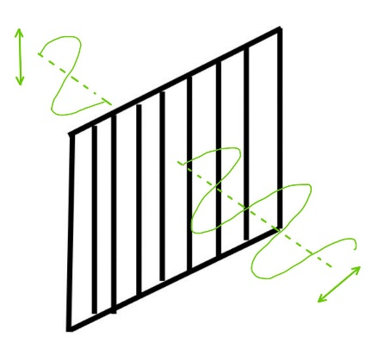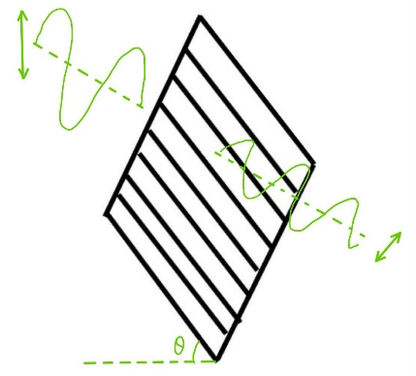d 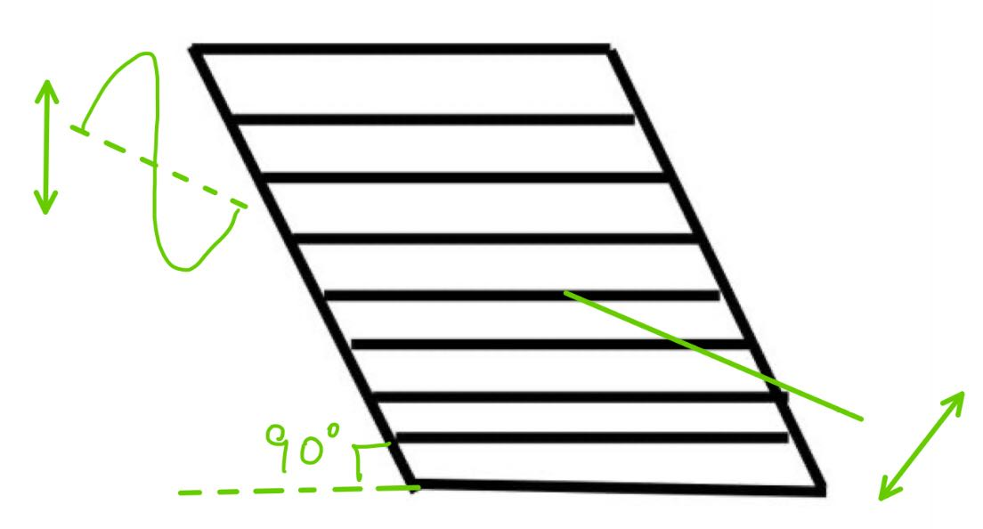

*Figure 10 - Rotating a wire grid*

**The relationship between the detected amplitude (indicate as ) and the angle is , where is the amplitude of the polarized light. Since there is a relationship between the intensity (indicated as ) and the amplitude , the expression above could be rewritten as which is called Malus’ Law [10].**

**Conclusion**

**During the lab, the concept of interference, diffraction and polarization have been introduced and the simulated phenomenon for each of them was shown by MATLAB. Data from physical lab has been provided to analyze the actual experiment and compare with the predicted result. During the process, students gained the self-study skill and the ability to explore the theory behind the concept and analyze the different between the expected data and the physical ones. Meanwhile, students gained the experience to derive an expression for the newly introduced theory based on the self-study and the learned mathematical theory (i.e., Fourier’s expansion, Euler’s formula, calculus and so on). The phenomenon of interference would be affected by the wavelength of the wave generated by the source and the path difference and the phase difference of the wave from each terminal of the rectangle waveguide. Both kinds of difference (i.e., the path difference and the phase difference) were detected by the horn. Diffraction could be divided into Fresnel diffraction (known as near field diffraction) and Fraunhofer diffraction (known as far field diffraction) in terms of the distance between the source, the opening (or the obstacle) and the detector. The phenomenon of diffraction would be impacted by the wavelength of the wave generated by the source, the number of the order of the diffraction and the distance between the source, the opening (or the obstacle) and the detector. Polarization mainly describes the orientation of the wave. Polarization would only occur if the wave is transverse wave instead of longitudinal wave. When the direction of the points in the wave is horizontal to the orientation of the polarizer, the detected intensity detected after the polarizer is maximum (i.e., ideally, there is no deduction when passing through the polarizer). However, if the direction of the points in the wave is perpendicular to the orientation of the polarizer, the detected intensity detected after the polarizer is minimum (i.e., ideally, it would be zero). All of those characteristics of waves would benefit in medical testing, the design of concert hall, glasses (i.e., anti-glare sunglasses, blue-light-blocking glasses, 3D glasses, etc.) and so on.**

**Reference**

**[1] ELEC0019 lecturer (2022, January). *Interference.m* [Online]. Available:** <https://moodle.ucl.ac.uk/pluginfile.php/3285570/mod_resource/content/1/Interference.m>

**[2] ELEC0019 lecturer (2022, January). *Int1.txt – Data from lab experiment* [Online]. Available:** <https://moodle.ucl.ac.uk/pluginfile.php/3285572/mod_resource/content/1/Int1.txt>

**[3] Mortimer Abramowitz, Matthew J. Parry-Hill and Michael W. Davidson (2015). *Optical Path Difference* [Online]. Available:** <https://www.olympus-lifescience.com/en/microscope-resource/primer/java/contrast/phaserefract/>

**[4] University of Cambridge (2012). *The dielectric constant and the refractive index* [Online]. Available:** <https://www.doitpoms.ac.uk/tlplib/dielectrics/dielectric_refractive_index.php>

**[5] ELEC0019 lecturer, “**Experiment 1.2 Measurement of relative permittivity of a dielectric material,**” in *ELEC0019 Interference, Diffraction and Polarization of Electromagnetic Waves*. 2022, pp. 5.**

**[6] ELEC0019 lecturer (2022, January). *Int2.txt – Data from lab experiment* [Online]. Available:** <https://moodle.ucl.ac.uk/pluginfile.php/3285575/mod_resource/content/1/Int2.txt>

**[7] University of Manchester. *13. Fresnel diffraction* [Online]. Available:** <https://www.hep.manchester.ac.uk/u/xiaguo/waveoptics/Fresnel%20diffraction.pdf>

**[8] Zhang Dachang, Peng Qiancheng *et al.*, “机械波,” (Mechanical Wave) in *物理 选修3-4* (*Physics Electives 3-4*), 2nd ed. Beijing, China: Educ., 2007, ch. 12, sec. 5, pp. 37-38.**

**[9] Loenen, S.J.H., “Fresnel diffraction on a semi-infinite opaque screen,” Eng., Eindhoven University of Technology, Eindhoven, Netherlands, Sci. Rep., 2015.**

**[10] E. Collett, “*Malus’ Law,*” in Field Guide to Polarization, Sci., SPIE Press, Bellingham, Washington, 2005.**

**[11] Lin Zhiyang, Lin Baoqing and Pu Jixiong, “波长和偏振依赖的分子强激光场单电离,” (Wavelength- and Polarization-Dependent Single Ionization of Molecules in Strong Laser Fields) Eng., School of Information Science and Engineering, Huaqiao University, Fujian, Key Laboratory of Optical Transmission and Transformation, Xiamen, China, Res. Rep., 2020.**

**[12] Isabelle Verrier, Thomas Kämpfe *et al*., “Wire-grid polarizer using galvanic growth technology: demonstration of a wide spectral and angular bandwidth component with high extinction ratio,” Sci., University of Eastern Finland, Department of Physics and Mathematics, P.O. Box 111, Yliopistokatu 7, Joensuu FI-80101, Finland, Exxelia Group, Eurofarad Department Capteurs et Systèmes Associés,1 rue des Temps Modernes, Chanteloup-en-Brie F-77600, France, Res. Rep., 2015.**

**Appendix**

**Q2.** ***Graph 1:*****The modified MATLAB code is shown below, named as “Interference.m**”.

% Script to model the interference between 2 point sources

% separated by a distance d and on a line parallel to a screen

% at a distance D.

% variables names as in Fig. 1 in the lab. script

%

% CHANGE THESE VALUES ACCORDING TO YOUR EXPERIMENTAL SETUP:

d=0.63; % separation between the sources (in m)

D=2.55; % distance from sources to screen (in m)

lambda=0.03; % wavelength (in m)

k=2*pi/lambda;

% eqn. (1)

x=-0.5:0.001:0.5; % to cover 50 cm at either side of the centre

theta1=atan((d/2-x)/D);

theta2=atan((d/2+x)/D);

l1=D./cos(theta1);

l2=D./cos(theta2);

j=0+1i;

Et=exp(-j*k*l1)./l1+exp(-j*k*l2)./l2;

Et=Et.*conj(Et)/(max(Et)^2);

% plot eqn. (1)

y=x*100; % converting to cm

plot(y,abs(Et))

axis([-50 50 0 1.2]);

set(gca,'XTick',-50:10:50)

title('{\bfInterference pattern}','FontSize',14)

xlabel('{\bfDistance from the centre of screen (in cm)}')

ylabel('{\bfRelative Intensity}')

line([0 0],[0 1.2])

% line([-0.5 0.5],[1 1],'linestyle',':')

% text(-0.48, 1.1,'drawn by {\bf <...insert your name here...> }')

hold on

% eqn. (4)

x=-0.5:0.001:0.5; % to cover 50 cm at either side of the centre

Et=4/D^2.*(cos(k*d.*x./2/D)).^2;

Et=Et./max(Et);

% plot eqn. (4)

y=x*100; % converting to cm

plot(y,abs(Et))

legend("eqn. (1)", "Central", "eqn. (4)")

***Graph 2:***

x = 0:0.001:0.31;

y1 = x;

y2 = sin(x);

plot(x,y1);

hold on;

plot(x,y2);

diff = y1-y2;

plot(x,diff);

legend("y=x","y=sin(x)","Difference");

xlabel("theta (degree)");

ylabel("y");

title("Comparison of y=x and y=sin(x)");

grid on;

***Graph 3:***

x = 0:0.001:0.31;

y1 = 1-x.^2./2;

y2 = cos(x);

plot(x,y1);

hold on;

plot(x,y2);

diff = y1-y2;

plot(x,diff);

legend("y=1-x^2/2","y=cos(x)","Difference");

xlabel("theta (degree)");

ylabel("y");

title("Comparison of y=1-x^2/2 and y=cos(x)");

grid on;

***Q4. Graph 4:* The MATLAB code for the comparison between the received signal and the expected one is shown below which is named “Pattern1.m**”.

data = load('C:\Users\DELL\Desktop\ELEC0019 Lab\Int1.txt'); % import data from the computer

x = data(:,1);

V = data(:,2);

Vmax = max(V); % find the maximum value from V

relative = V./Vmax; % normalize V

r = relative.^2;

plot(x,r);

% Script to model the interference between 2 point sources

% separated by a distance d and on a line parallel to a screen

% at a distance D.

% variables names as in Fig. 1 in the lab. script

%

% CHANGE THESE VALUES ACCORDING TO YOUR EXPERIMENTAL SETUP:

d=0.63; % separation between the sources (in m)

D=2.55; % distance from sources to screen (in m)

lambda=0.03; % wavelength (in m)

k=2*pi/lambda;

%

x=-0.36:0.001:0.36; % to cover 50 cm at either side of the centre

theta1=atan((d/2-x)/D);

theta2=atan((d/2+x)/D);

l1=D./cos(theta1);

l2=D./cos(theta2);

j=0+1i;

Et=exp(-j*k*l1)./l1+exp(-j*k*l2)./l2;

Et=Et.*conj(Et)/(max(Et)^2);

%

y=x*100; % converting to cm

hold on

plot(y,abs(Et))

axis([-36 36 0 1.2]);

set(gca,'XTick',-36:6:36)

title('{\bfInterference pattern}','FontSize',14)

xlabel('{\bfDistance from the centre of screen (in cm)}')

ylabel('{\bfRelative Intensity}')

line([0 0],[0 1.2])

legend("Int1.txt", "Ideal", "Central")

% line([-0.4 0.4],[1 1],'linestyle',':')

% text(-0.48, 1.1,'drawn by {\bf <...insert your name here...> }')

***Graph 5:***

% Script to model the interference between 2 point sources

% separated by a distance d and on a line parallel to a screen

% at a distance D.

% variables names as in Fig. 1 in the lab. script

%

% CHANGE THESE VALUES ACCORDING TO YOUR EXPERIMENTAL SETUP:

d=0.63; % separation between the sources (in m)

D=2.55; % distance from sources to screen (in m)

lambda=0.03; % wavelength (in m)

k=2*pi/lambda;

% eqn. (1)

x=-0.5:0.001:0.5; % to cover 50 cm at either side of the centre

theta1=atan((d/2-x)/D);

theta2=atan((d/2+x)/D);

l1=D./cos(theta1);

l2=D./cos(theta2);

j=0+1i;

Et=exp(-j*k*l1)./l1+exp(-j*k*l2)./l2;

Et=Et.*conj(Et)/(max(Et)^2);

% plot eqn. (1)

y=x*100; % converting to cm

plot(y,abs(Et))

axis([-50 50 0 1.2]);

set(gca,'XTick',-50:10:50)

title('{\bfInterference pattern}','FontSize',14)

xlabel('{\bfDistance from the centre of screen (in cm)}')

ylabel('{\bfRelative Intensity}')

line([0 0],[0 1.2])

% line([-0.5 0.5],[1 1],'linestyle',':')

% text(-0.48, 1.1,'drawn by {\bf <...insert your name here...> }')

hold on

% eqn. (4)

x=-0.5:0.001:0.5; % to cover 50 cm at either side of the centre

Et=4/D^2.*(cos(k*d.*x./2/D)).^2;

Et=Et/max(Et);

% plot eqn. (4)

y=x*100; % converting to cm

plot(y,abs(Et))

% Int1.txt

data = load('C:\Users\DELL\Desktop\ELEC0019 Lab\Int1.txt');

x = data(:,1);

V = data(:,2);

Vmax = max(V);

relative = V./Vmax;

r = relative.^2;

plot(x,r);

legend("eqn. (1)", "Central", "eqn. (4)", "Int1.txt")

**Q6. *Graph 6:* The MATLAB code for the comparison between the received signal and the expected one is shown below which is named “ShiftedPattern.m”.**

data = load('C:\Users\DELL\Desktop\ELEC0019 Lab\Int1.txt'); % import the data from txt file to matlab

x = data(:,1); % distance

V = data(:,2); % voltage

Vmax = max(V); % find the maximum voltage

relative = V./Vmax; % modify

r = relative.^2; % calculate the relative intensity

plot(x,r); % plot the graph

hold on; % plot another graph on the same figure

data1 = load('C:\Users\DELL\Desktop\ELEC0019 Lab\Int2.txt'); % import the data from txt file to matlab

x1 = data1(:,1); % distance

V1 = data1(:,2); % voltage

Vmax1 = max(V1); % find the maximum voltage

relative1 = V1./Vmax1; % modify

r1 = relative1.^2; % calculate the relative intensity

plot(x1,r1); % plot the graph

title('{\bfInterference pattern}','FontSize',14) % name the graph

xlabel('{\bfDistance from the centre of screen (in cm)}') % name the x-axis

ylabel('{\bfRelative Intensity}') % name the y-axis

line([0 0],[0 1.2]) % plot the center

legend("Int1.txt", "Int2.txt", "Central") % name the curve

***Figure 3:***

data = load('C:\Users\DELL\Desktop\ELEC0019 Lab\Int1.txt'); % import the data from txt file to matlab

x = data(:,1); % distance

V = data(:,2); % voltage

Vmax = max(V); % find the maximum voltage

relative = V./Vmax; % modify

r = relative.^2; % calculate the relative intensity

data1 = load('C:\Users\DELL\Desktop\ELEC0019 Lab\Int2.txt'); % import the data from txt file to matlab

x1 = data1(:,1); % distance

V1 = data1(:,2); % voltage

Vmax1 = max(V1); % find the maximum voltage

relative1 = V1./Vmax1; % modify

r1 = relative1.^2; % calculate the relative intensity

% initialise

i = 1;

k = 1;

xm = zeros(1,6);

xm1 = zeros(1,6);

for id = 2:length(x)-1

if ((r(id) > r(id-1)) && (r(id) > r(id+1))) % find the maxima

xm(i) = x(id); % record the x coordinate for each maxima

i = i + 1;

end

xm(6) = x(end);

end

for id1 = 2:length(x1)-1

if ((r1(id1) > r1(id1-1)) && (r1(id1) > r1(id1+1))) % find the maxima

xm1(k) = x1(id1); % record the x coordinate for each maxima

k = k + 1;

end

end

shift = xm1 - xm; % calculate the shift by shifted - initial

disp("The shift for the first maxima is "+shift(1)+".")

disp("The shift for the second maxima is "+shift(2)+".")

disp("The shift for the third maxima is "+shift(3)+".")

disp("The shift for the fourth maxima is "+shift(4)+".")

disp("The shift for the fifth maxima is "+shift(5)+".")

disp("The shift for the sixth maxima is "+shift(6)+".")

Shift = sum(shift)/length(shift); % calculate the mean shift

disp("The shift is "+Shift+".")

ym = max(r); % find the maxima for the initial

id2 = find(r == ym); % find its index

xm2 = x(id2); % find its x coordinate

ym1 = max(r1); % find the maxima for the shifted

id3 = find(r1 == ym1); % find its index

xm3 = x1(id3); % find its x coordinate

diff = xm3 - xm2; % find the shift

disp("The shift for the center is "+diff+".")

***Q7. Graph 7 – Graph 12:*** The MATLAB code to plot array factor which is named as “**Array.m**”.

kd = [pi, pi/2]; % define the value of the product of kd

phase = [0, pi/2, pi]; % define the value of phase difference

theta = 0:0.01:2*pi; % the range of the value of theta

count = 0; % initialise count

for k = 1:2 % plot graphs with different kd

for j = 1:3 % plot graphs with different phase

F = abs(1+exp(1i*phase(j)+1i*kd(k)*cos(theta))); % calculate the value of F

F = F/max(F); % normalise

count = count + 1; % count the number of the figure

figure(count);

polarplot(theta,F); % plot a graph in polar system

end

end

% name the curve in each figure

figure(1);

legend("d=λ/2, φ=0");

figure(2);

legend("d=λ/2, φ=90");

figure(3);

legend("d=λ/2, φ=180");

figure(4);

legend("d=λ/4, φ=0");

figure(5);

legend("d=λ/4, φ=90");

figure(6);

legend("d=λ/4, φ=180");

***Q10. Graph 13:***

M = xlsread('diffraction.xlsx'); % import the data from xlsx file to matlab

xr = M(:, 1); % distance

i = M(:, 2); % intensity

x0 = 92.3;

x = x0 - xr;

I = 0.3492; % steady value

In = i./I; % normalisation

plot(x, In, 'k'); % plot the graph

title('{\bfDiffraction pattern}','FontSize',14) % name the graph

xlabel('{\bfPosition of the screen edge (in cm)}') % name the x-axis

ylabel('{\bfRelative Intensity}') % name the y-axis

line([0 0],[0 1.6])

line([-10 50],[0.25 0.25])

legend("Diffraction", "x = 0", "intensity = 0.25") % name each curve

grid on;

***Q11. Graph 14:***

I0 = 0.5; % the intensity of the polarized light

theta = 0 : 360; % rotate one circle

I = I0 * (cosd(theta)).^2; % expression for intensity

plot(theta, I);

grid on;

title('{\bfRotating intensity}','FontSize',14)

xlabel('{\bfAngle (in degree)}')

ylabel('{\bfIntensity (W/m^2)}')